21.39: a) Let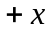 be east.
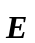 is west and is negative, so 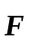 is east and the electron speeds up.
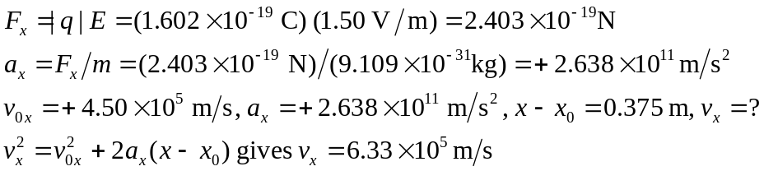
b) 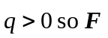 is west and the proton slows down.
